Question 1

Write a c program which reads in a text file and finds all the identifiers in the
file. An identifier is a token (sequence of characters) that starts with an
underscore or a letter and continues with underscores or letters or digits.
You are to sort all the identifiers in the input text file and output them in
alphabetical order.
You are also to output the line numbers on which the identifier occurred.

Solution:

#include <stdio.h>
#include <stdlib.h>
#include <string.h>
#include <ctype.h>

// Function to check if a character is a valid part of an identifier
int isValidIdentifierChar(char c) {
return isalnum(c) || c == '_';
}

int main() {
char filename[100];
printf("Enter the name of the input text file: ");
scanf("%s", filename);

FILE* file = fopen(filename, "r");
if (file == NULL) {
printf("Failed to open the file.\n");
return 1;
}

char line[1024];
int lineNum = 0;
char identifiers[1000][50]; // Adjust the size and identifier length as needed
int lineNumbers[1000][100]; // Adjust the size as needed
int identifierCount = 0;

while (fgets(line, sizeof(line), file)) {
lineNum++;
char* token = strtok(line, " \t\n");
while (token != NULL) {
if (isalpha(token[0]) || token[0] == '_') {
int len = strlen(token);
int isIdentifier = 1;
for (int i = 1; i < len; i++) {
if (!isValidIdentifierChar(token[i])) {
isIdentifier = 0;
break;
}
}
if (isIdentifier) {
int found = 0;
for (int i = 0; i < identifierCount; i++) {
if (strcmp(identifiers[i], token) == 0) {
lineNumbers[i][lineNumbers[i][0] + 1] = lineNum;
lineNumbers[i][0]++; // Increment line number count
found = 1;
break;
}
}
if (!found) {
strcpy(identifiers[identifierCount], token);
lineNumbers[identifierCount][0] = 1; // Set line number count to 1
lineNumbers[identifierCount][1] = lineNum;
identifierCount++;
}
}
}
token = strtok(NULL, " \t\n");
}
}

fclose(file);

// Sort the identifiers in alphabetical order
for (int i = 0; i < identifierCount - 1; i++) {
for (int j = i + 1; j < identifierCount; j++) {
if (strcmp(identifiers[i], identifiers[j]) > 0) {
char temp[50];
strcpy(temp, identifiers[i]);
strcpy(identifiers[i], identifiers[j]);
strcpy(identifiers[j], temp);

int tempLineNumbers[100];
memcpy(tempLineNumbers, lineNumbers[i], sizeof(lineNumbers[i]));
memcpy(lineNumbers[i], lineNumbers[j], sizeof(lineNumbers[j]));
memcpy(lineNumbers[j], tempLineNumbers, sizeof(tempLineNumbers));
}
}
}

printf("Identifiers in alphabetical order and their line numbers:\n");
for (int i = 0; i < identifierCount; i++) {
printf("%s:", identifiers[i]);
for (int j = 1; j <= lineNumbers[i][0]; j++) {
printf(" %d", lineNumbers[i][j]);
}
printf("\n");
}

return 0;
}

Question 2

The modified code is in the file traffic-model.c. Below is a screenshot of the output after running that code, simulating the traffic light model.

When you press E – it renders: 33 (as it was going North Initially goN), 34 (WaitN) , 12 (goE)
When you press N – it renders: 20 (WaitE), 33(goN)
When you press B – it renders: 34(WaitN), 12(goE) , 20(WaitE), 33(goN), 34,12
When you press L(any other key) – it renders: 12,12 (It keeps rendering the signal that was last executed)

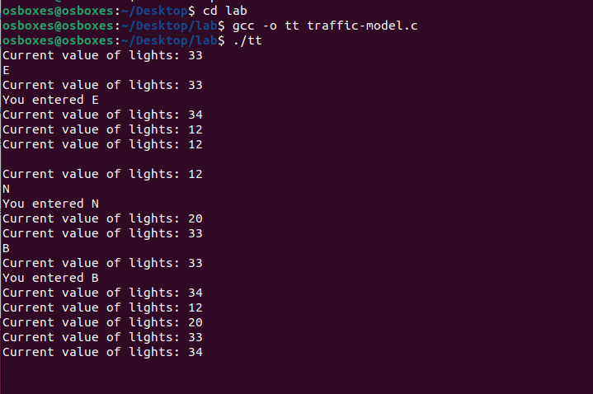

Question 3

static uint64_t pl011_read(void *opaque, hwaddr offset,
unsigned size)
{
PL011State *s = (PL011State *)opaque;
uint32_t c;
uint64_t r;

PL011State *s = (PL011State *)opaque;: This line retrieves a pointer to the PL011State from the opaque parameter. The s variable will be used to access the UART's internal state.

uint32_t c; uint64_t r;: Two variables c and r are declared to store temporary data and the final result of the read operation.

The function uses a switch statement based on the offset (register address) divided by 4 (offset >> 2). The UART registers are read based on their offset addresses.

switch (offset >> 2) {
case 0: /* UARTDR */
s->flags &= ~PL011_FLAG_RXFF;
c = s->read_fifo[s->read_pos];
if (s->read_count > 0) {
s->read_count--;
s->read_pos = (s->read_pos + 1) & (pl011_get_fifo_depth(s) - 1);
}
if (s->read_count == 0) {
s->flags |= PL011_FLAG_RXFE;
}
if (s->read_count == s->read_trigger - 1)
s->int_level &= ~ INT_RX;
trace_pl011_read_fifo(s->read_count);
s->rsr = c >> 8;
pl011_update(s);
qemu_chr_fe_accept_input(&s->chr);
r = c;
break;

case 0: /* UARTDR */: Reads the UART Data Register.

- It clears the receive FIFO full flag (PL011_FLAG_RXFF).
- Reads a character from the read FIFO (s->read_fifo).
- Decreases the read count and updates the read position.
- Sets the receive FIFO empty flag (PL011_FLAG_RXFE) if the read count reaches 0.
- Updates the interrupt level when necessary (s->int_level).
- Records the received status register (s->rsr).
- Calls the pl011_update function.
- Accepts input for the UART character device (&s->chr).
- The read result r is set to the character c.

case 1: /* UARTRSR */
r = s->rsr;
break;

case 1: /* UARTRSR */: Reads the UART Receive Status Register (s->rsr) and stores it in r.

case 6: /* UARTFR */
r = s->flags;
break;

case 6: /* UARTFR */: Reads the UART Flag Register (s->flags) and stores it in r.

case 8: /* UARTILPR */
r = s->ilpr;
break;

case 8: /* UARTILPR */: Reads the UART IrDA Low-Power Counter Register (s->ilpr) and stores it in r.

case 9: /* UARTIBRD */
r = s->ibrd;
break;

case 9: /* UARTIBRD */: Reads the UART Integer Baud Rate Divisor Register (s->ibrd) and stores it in r.

case 10: /* UARTFBRD */
r = s->fbrd;
break;

case 10: /* UARTFBRD */: Reads the UART Fractional Baud Rate Divisor Register (s->fbrd) and stores it in r.

case 11: /* UARTLCR_H */
r = s->lcr;
break;

case 11: /* UARTLCR_H */: Reads the UART Line Control Register (s->lcr) and stores it in r.

case 12: /* UARTCR */
r = s->cr;
break;

case 11: /* UARTLCR_H */: Reads the UART Line Control Register (s->lcr) and stores it in r.

case 13: /* UARTIFLS */
r = s->ifl;
break;

case 13: /* UARTIFLS */: Reads the UART Interrupt FIFO Level Select Register (s->ifl) and stores it in r.

case 14: /* UARTIMSC */
r = s->int_enabled;
break;

case 14: /* UARTIMSC */: Reads the UART Interrupt Mask Set/Clear Register (s->int_enabled) and stores it in r.

case 15: /* UARTRIS */
r = s->int_level;
break;

case 15: /* UARTRIS */: Reads the UART Raw Interrupt Status Register (s->int_level) and stores it in r.

case 16: /* UARTMIS */
r = s->int_level & s->int_enabled;
break;

case 16: /* UARTMIS */: Reads the UART Masked Interrupt Status Register, which is a combination of s->int_level and s->int_enabled. The result is stored in r.

case 18: /* UARTDMACR */
r = s->dmacr;
break;

case 18: /* UARTDMACR */: Reads the UART DMA Control Register (s->dmacr) and stores it in r.

case 0x3f8 ... 0x400:
r = s->id[(offset - 0xfe0) >> 2];
break;
default:
qemu_log_mask(LOG_GUEST_ERROR,
"pl011_read: Bad offset 0x%x\n", (int)offset);
r = 0;
break;
}

case 0x3f8 ... 0x400: Reads registers related to UART identification.

default: Handles any other unsupported offsets. It logs an error and sets the result r to 0.

trace_pl011_read(offset, r, pl011_regname(offset));
return r;
}

Finally, the function traces the read operation with information such as the offset, the result, and the name of the register being read.

The pl011_read function reads various registers in the PL011 UART controller, updates internal state, and handles different cases and error conditions.

